**Introduction:** The purpose of this project is to design a robust and interconnected network system for Johnson & Johnson, a company with five departments: Production, Research & Development, Finance, Sales & Marketing, and Human Resources. The goal is to create distinct sub-networks for each department while ensuring seamless communication and accessibility.

We will combine switches, hubs, routers, and PCs to establish the network infrastructure. Each department will have its dedicated sub-network, enabling efficient management of resources and secure data transmission within specific departments. The network design will also incorporate routing protocols to optimize traffic flow and ensure reliable connectivity throughout the organization.

Routers will be interconnected using serial connections to provide connectivity between the sub-networks. This will enable the exchange of data packets across the network, facilitating communication between departments.

Within each sub-network, we will connect a minimum of three PCs. These PCs will serve as workstations for the employees, enabling them to access shared resources and communicate with colleagues within their respective departments.

A single DHCP server will be deployed in the Human Resources sub-network to simplify IP address management. This server will assign IP addresses to all PCs in the five sub-networks, ensuring efficient utilization of IP space and centralized control over address allocation.

Furthermore, the network design will incorporate DNS and HTTP services to meet the specific requirements of the Research & Development and Sales & Marketing departments. These services will enable efficient domain name resolution and web access within these departments.

Regarding routing protocols, we will combine RIP, OSPF, and EIGRP. This multi-protocol approach will provide flexibility, redundancy, and scalability, ensuring efficient routing of data packets and fault tolerance within the network infrastructure.

Overall, this network design for Johnson & Johnson aims to create a reliable, secure, and interconnected system that enhances communication, promotes resource sharing, and facilitates efficient data transfer among the different departments.

**Subnetting procedure:**   
  
The given Ip was = 193.87.214.0/22

From this, we got the Network ID = 193.87.212.0/22  
  
Since we must create five networks for five departments, we must create five subnets from 193.87.212.0/22.

By taking the last 2 bits in the 3rd octet as Network ID, we can create the following four subnets-

1. *11000001.01010111.11010100*.00000000 = 193.87.212.0/24
2. *11000001.01010111.11010101*.00000000 = 193.87.213.0/24
3. *11000001.01010111.11010110*.00000000 = 193.87.214.0/24
4. *11000001.01010111.11010111*.00000000 = 193.87.215.0/24

To create enough subnets, we decided to divide 193.87.212.0/24 in half-

193.87.212.0/24 -> *11000001.01010111.11010100.0*0000000 = 193.87.212.0/25

*11000001.01010111.11010100.1*0000000 = 193.87.212.128/25

The final networks are -

1. Human Resources: 193.87.213.0/24
2. Research & Development: 193.87.214.0/24
3. Production: 193.87.212.0/25
4. Finance: 193.87.212.128/25
5. Sales & Marketing: 193.87.215.0/24

**Modules and Routing Protocols:** We used the 1941 Router in our project. After that, we added two extra ports (PT-SWITCH-NM-1CFE) to the switch. Because in a normal situation, we can add up to four ports. But here, we have to add more than four, so we added two extra for connecting the router and the server.

We have been asked to build a network with a single DHCP server in the Human Resources sub-network, and all the PCs in all five sub-networks will be assigned IP addresses using this DHCP server. Research & Development and Sales & Marketing network should have DNS and HTTP service.

First, we will go to the HR DHCP Server. This is static. Then we can see the DHCP option if we go to the services. Here we will add all the departments and their IP, Set the default gateway, and where to start. We also added the subnet for each of them.

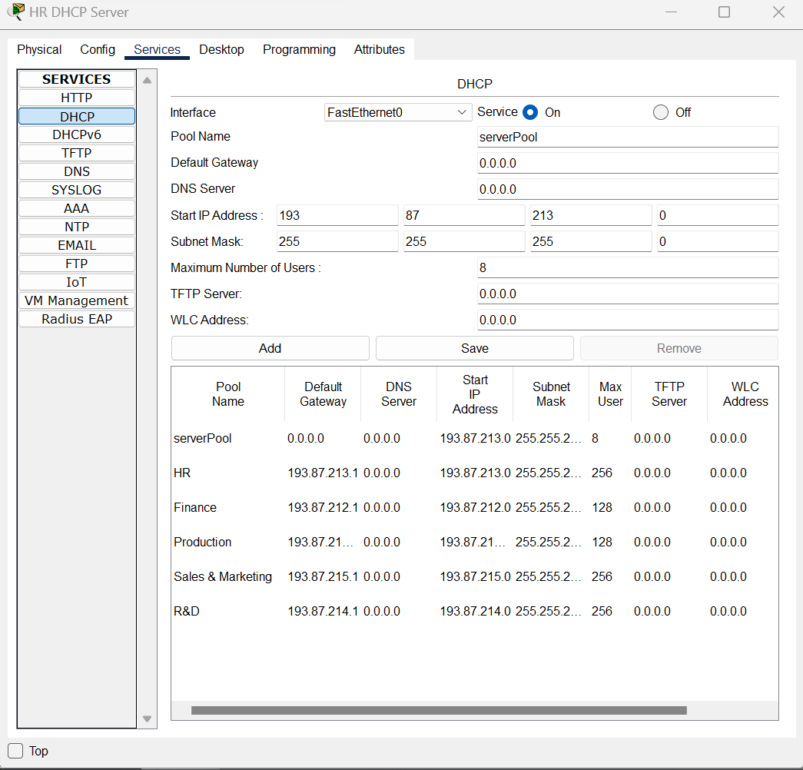

DHCP will have its configuration. Which will be static, and we will access this again and again.

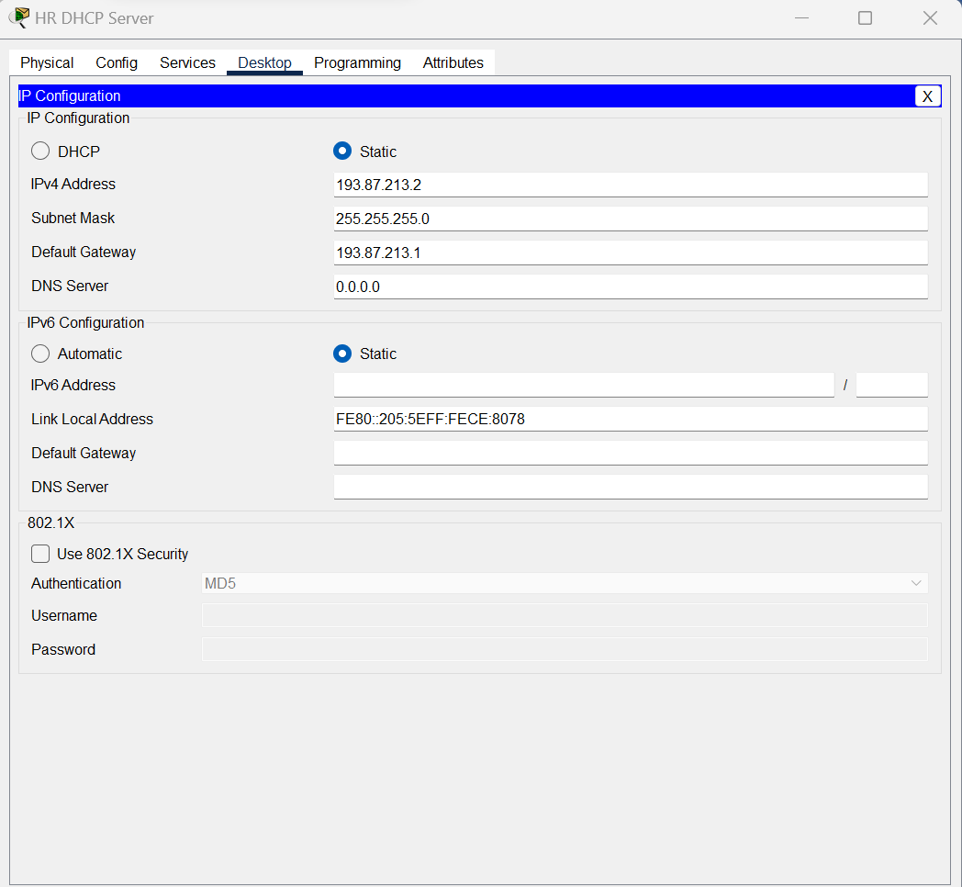

We will have three connections in the router. One is se0/1/1, and another is se0/1/0, and finally, Gig0/0.

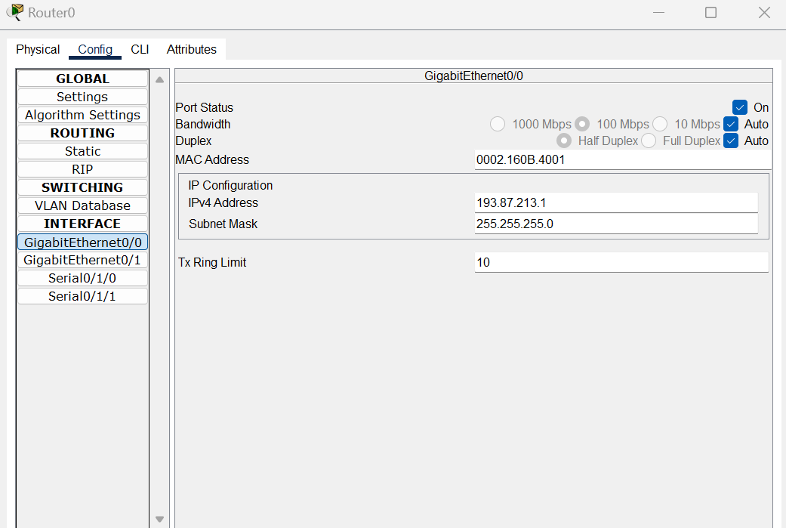

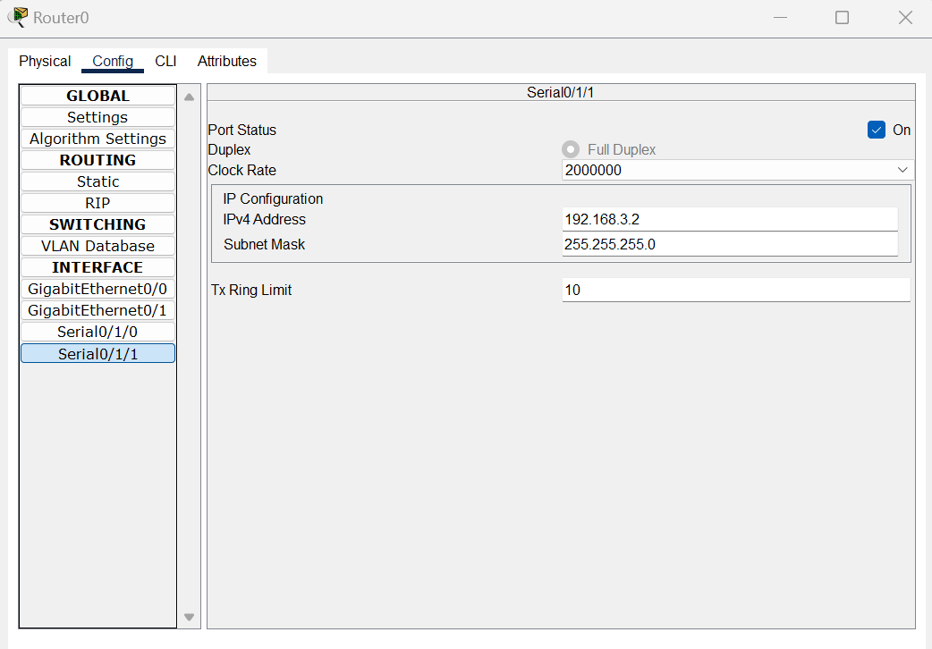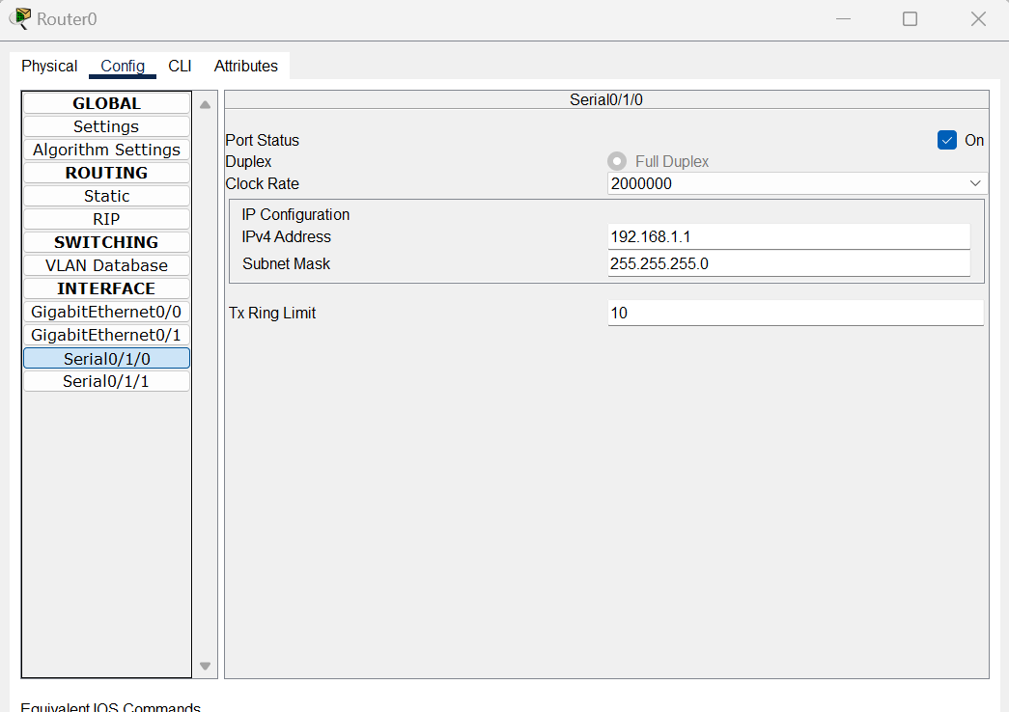

Then we added the network address in Routing IP/ RIP.

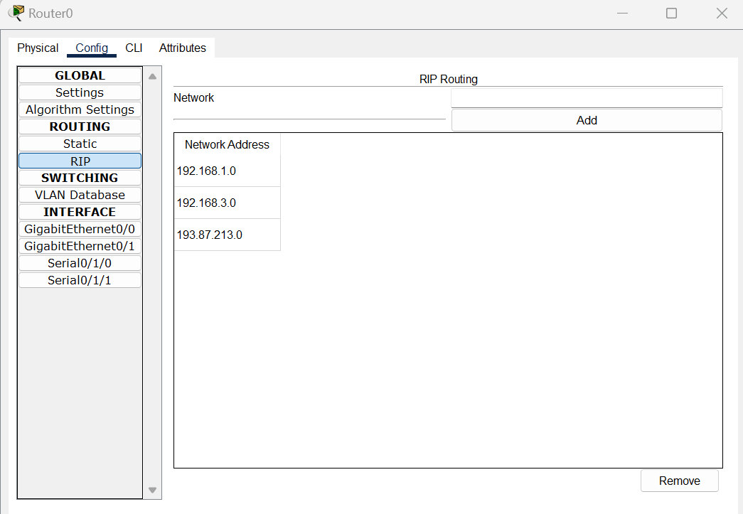

Similarly, we will connect all the others with the same process.

We are working with DHCP, so if we go to the PC setting and IP configuration toggle the static to DHCP, it will automatically fill up the IP, Subnet, and Default gateway.

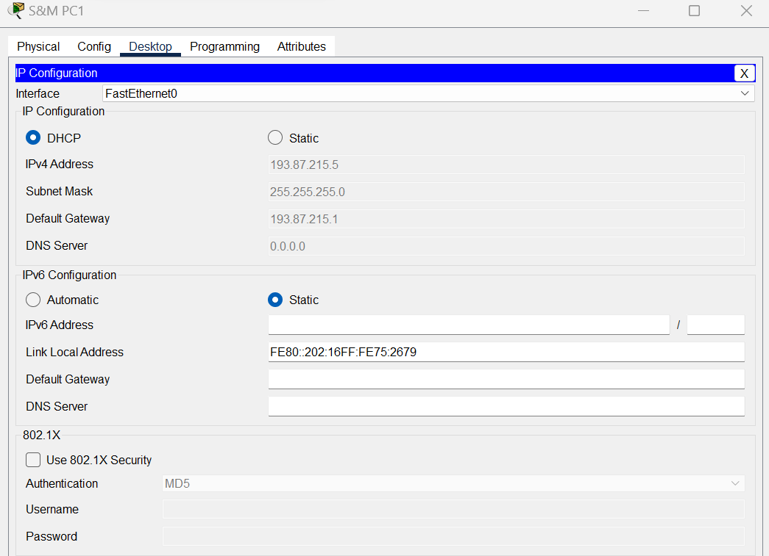

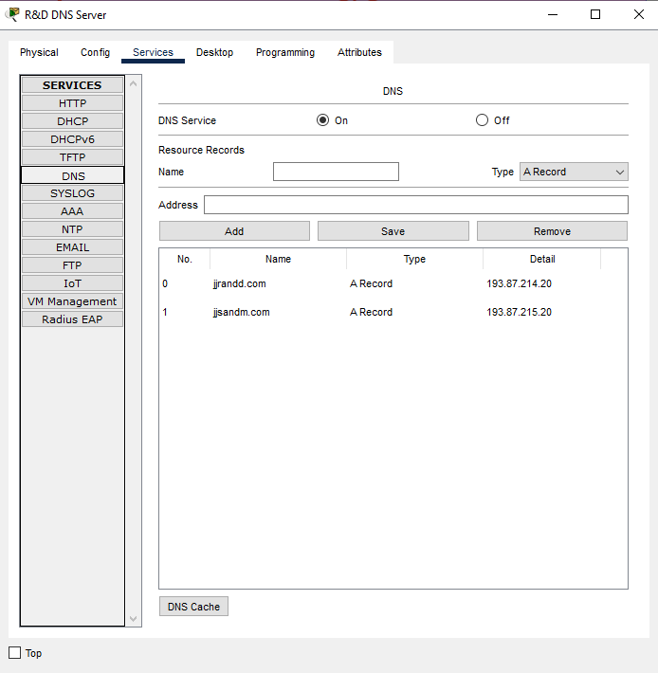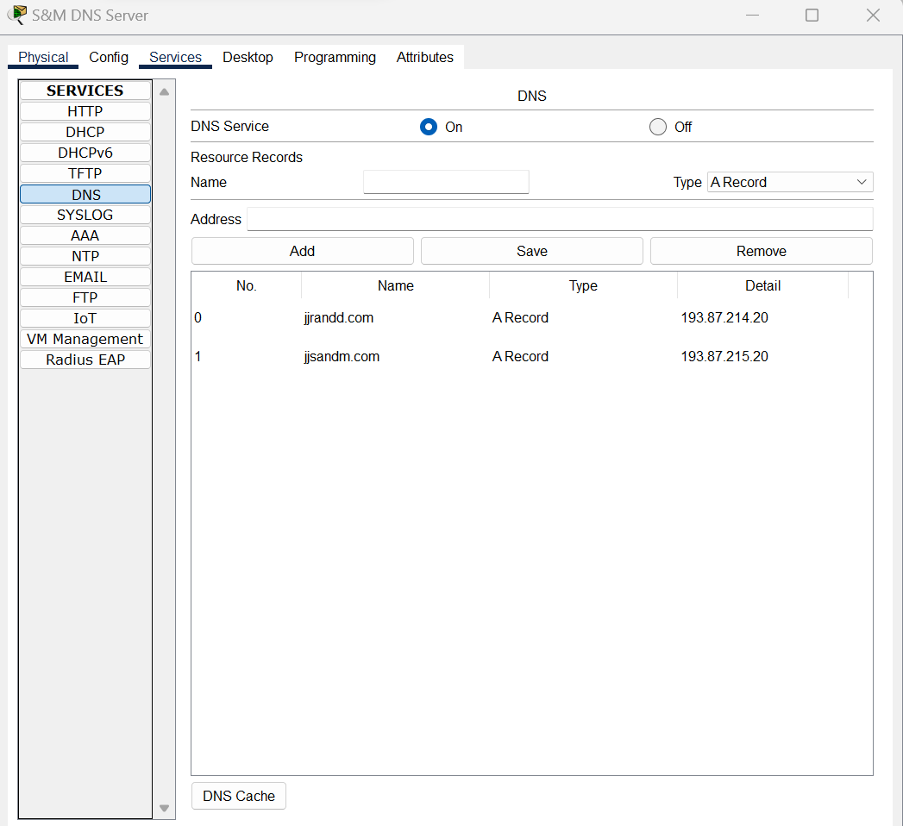Now the DNS server. First, go to the sales and marketing DNS server. Go to the services -DNS and add.

Fig: Sales and marketing DNS server Fig: Research and Development DNS server

*For router0 routing command:*

**FOR EIGRP-**

#exit

#router eigrp 1

#network 193.87.213.0 255.255.255.0

#network 192.168.1.0 255.255.255.0

#network 192.168.3.0 255.255.255.0

**FOR OSPF-**

#exit

#router ospf 1

#network 193.87.213.0 0.0.0.0. 255 area 21

#network 192.168.1.0 0.0.0.0.255 area 21

#network 192.168.3.0 0.0.0.0.255 area 21

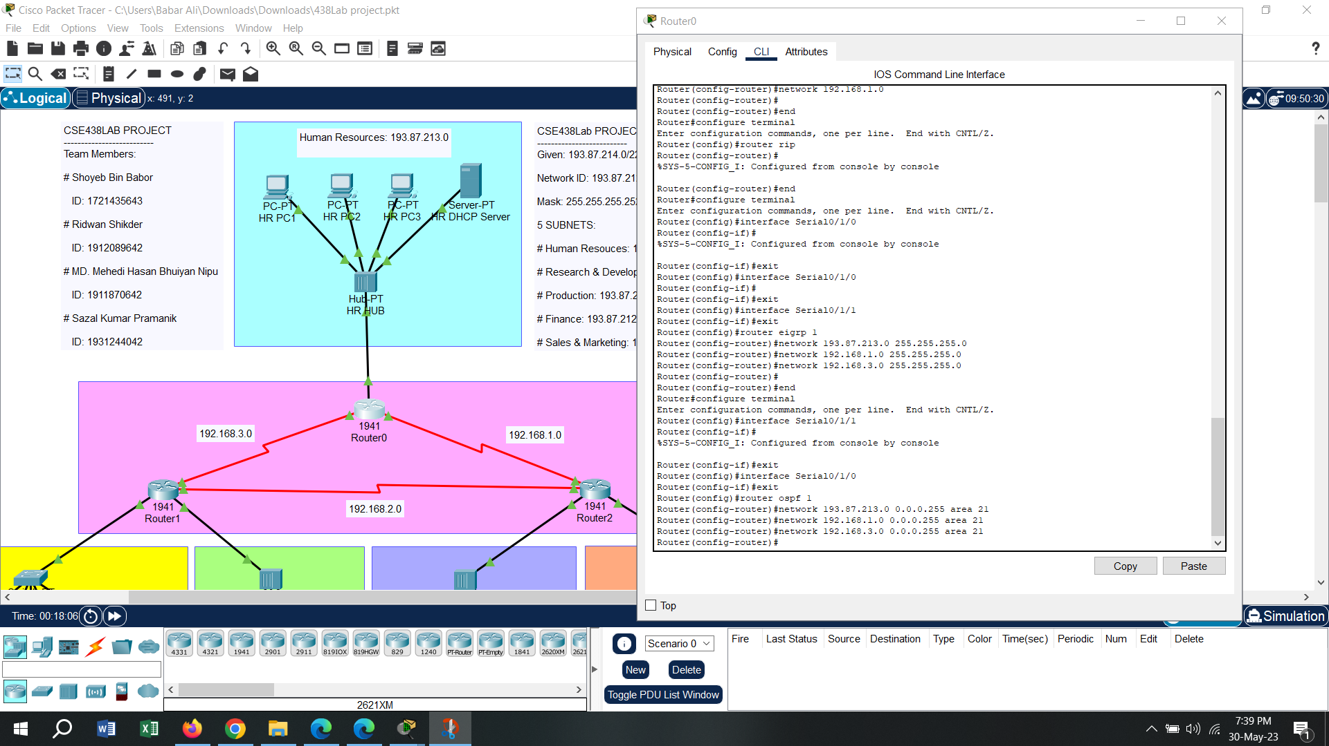

*For router1 routing command:*

**FOR EIGRP-**

#exit

#router eigrp 1

#network 192.168.3.0 255.255.255.0

#network 192.168.2.0 255.255.255.0

#network 193.87.215.0 255.255.255.0

#network 192.168.212.0 255.255.255.0

**FOR OSPF-**

#exit

#router ospf 1

#network 192.168.3.0 0.0.0.0. 255 area 21

#network 192.168.2.0 0.0.0.0.255 area 21

#network 193.87.215.0 0.0.0.0.255 area 21

#network 193.87.212.0 0.0.0.0.255 area 21

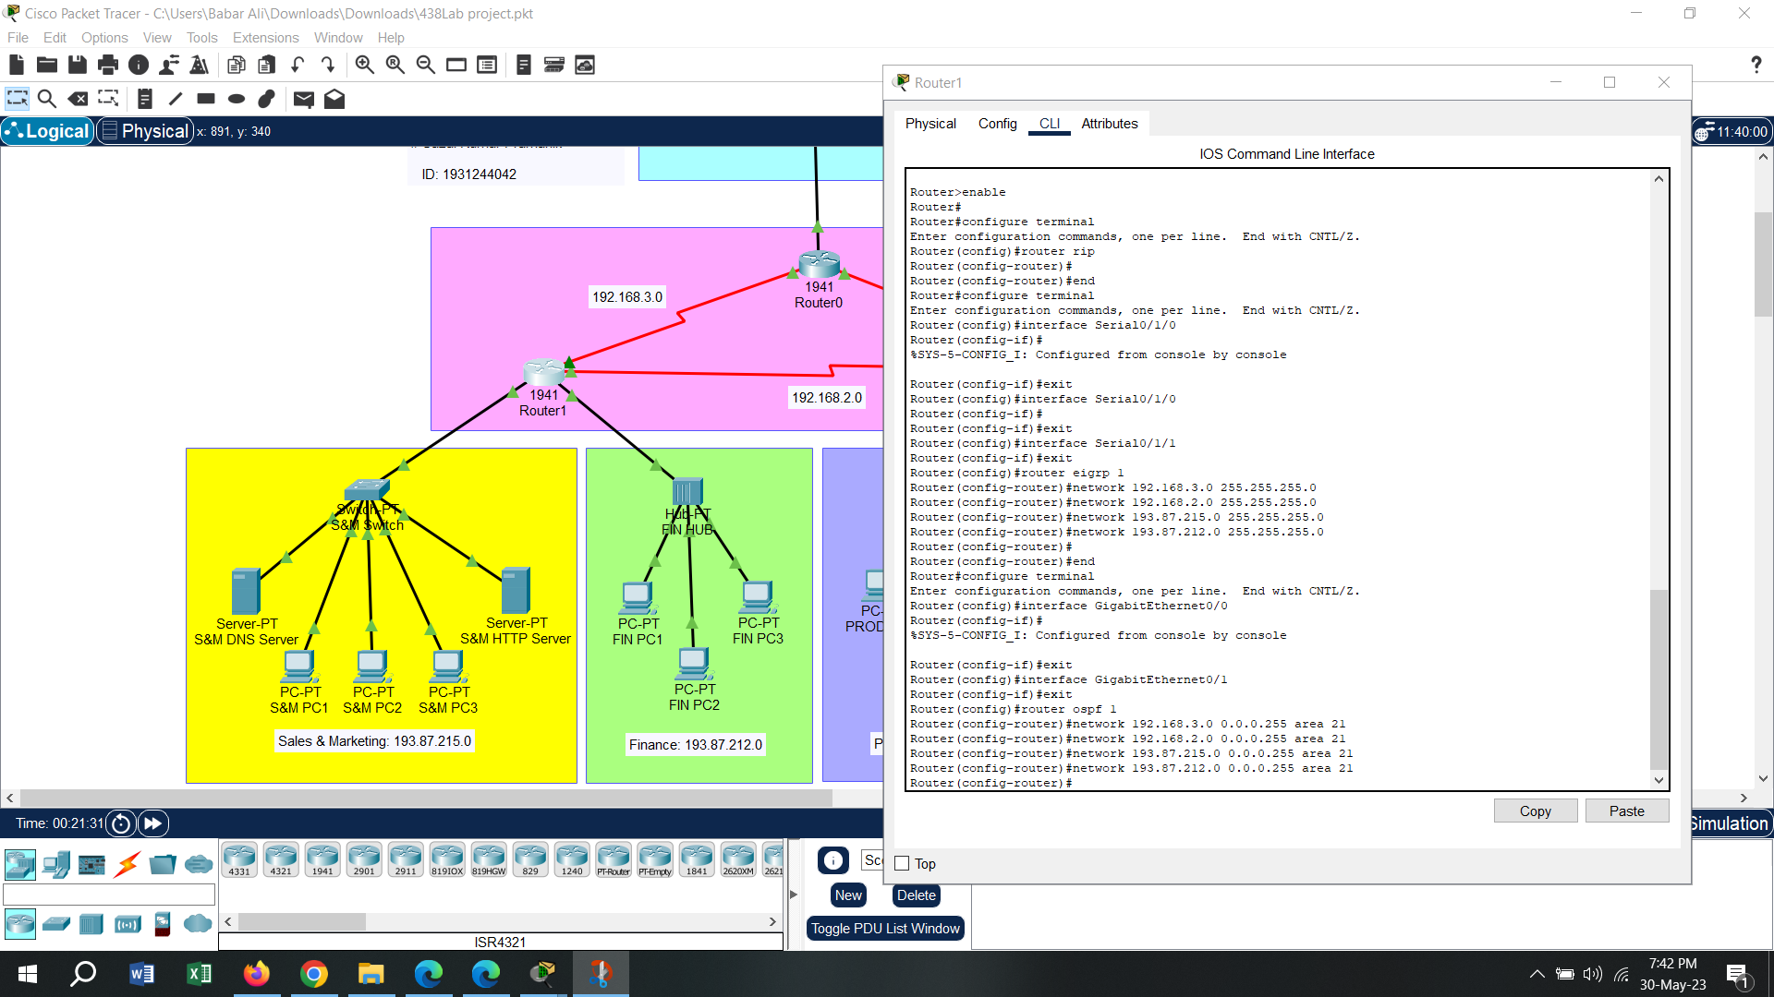

*For router2 routing command:*

**FOR EIGRP-**

#exit

#router eigrp 1

#network 192.168.1.0 255.255.255.0

#network 192.168.2.0 255.255.255.0

#network 193.87.212.128 255.255.255.0

#network 192.168.214.0 255.255.255.0

**FOR OSPF-**

#exit

#router ospf 1

#network 192.168.1.0 0.0.0.0. 255 area 21

#network 192.168.2.0 0.0.0.0.255 area 21

#network 193.87.212.128 0.0.0.0.127 area 21

#network 193.87.214.0 0.0.0.0.255 area 21

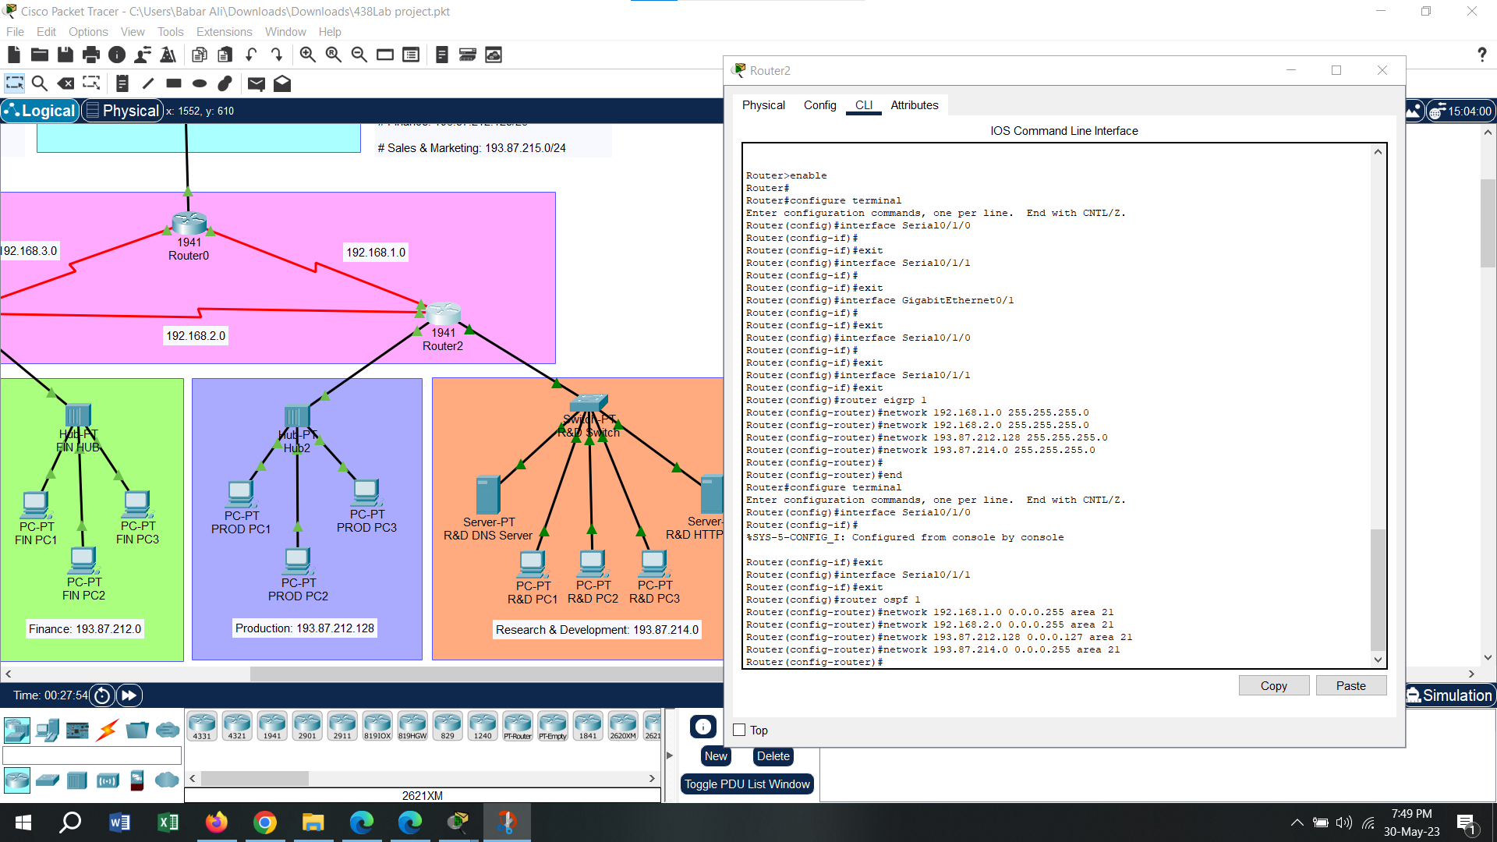

**Results & Discussion:**

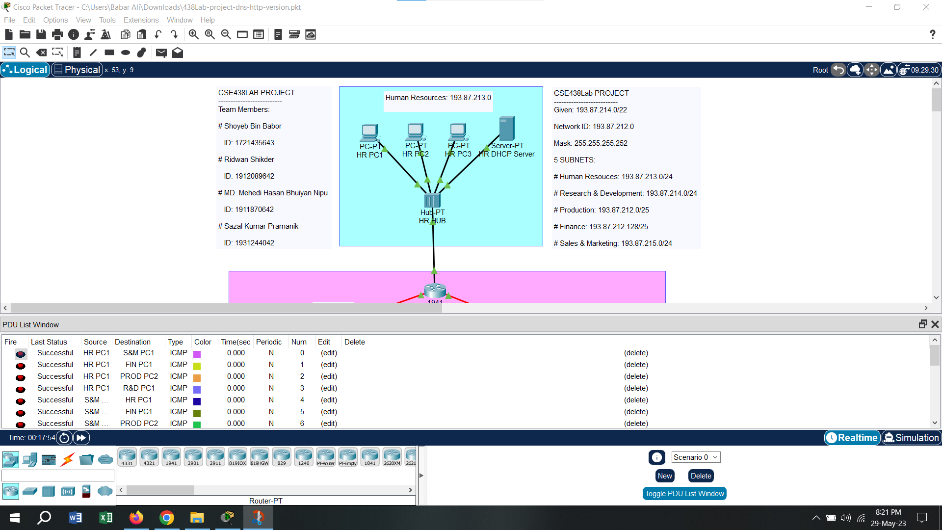

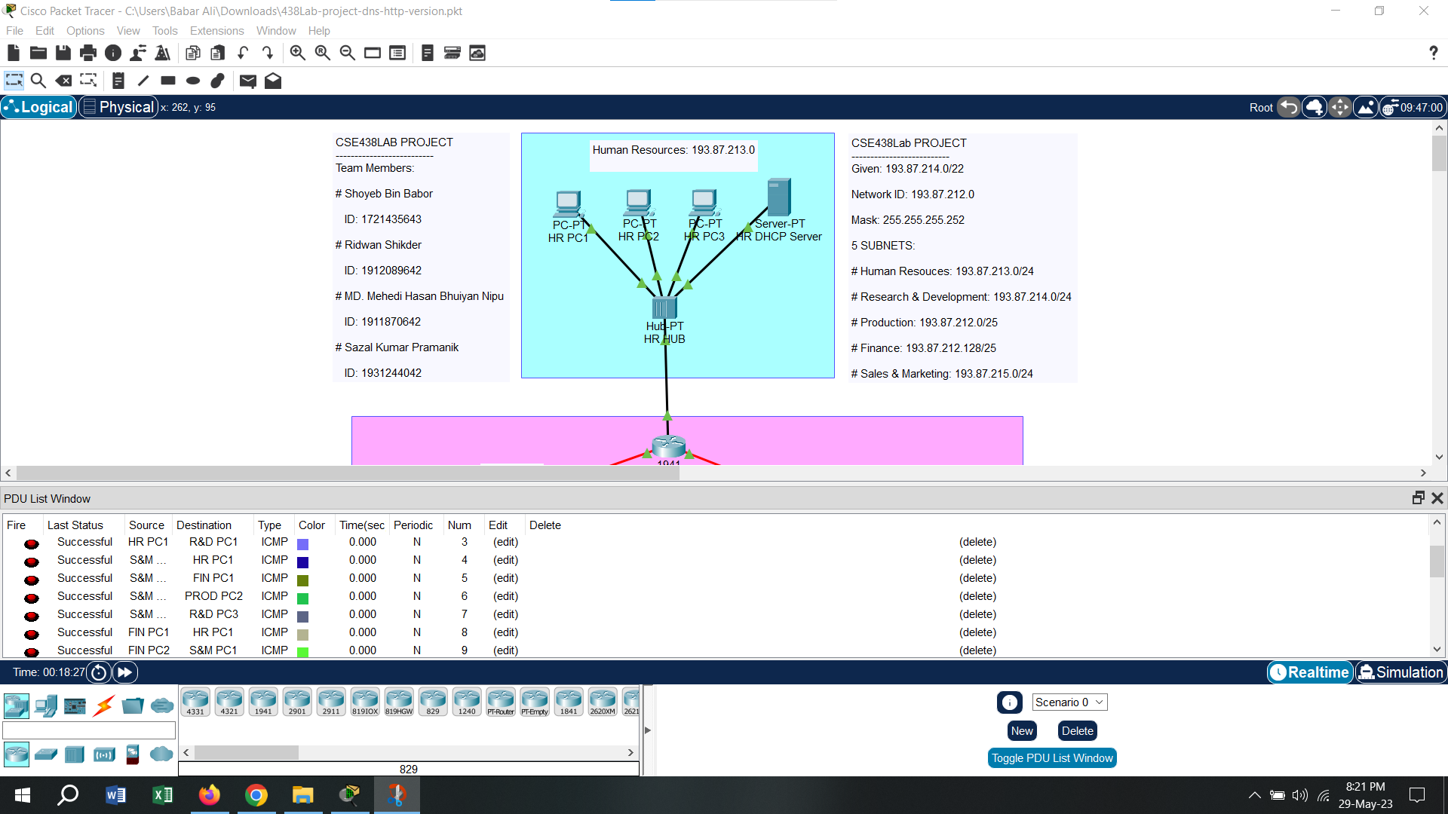

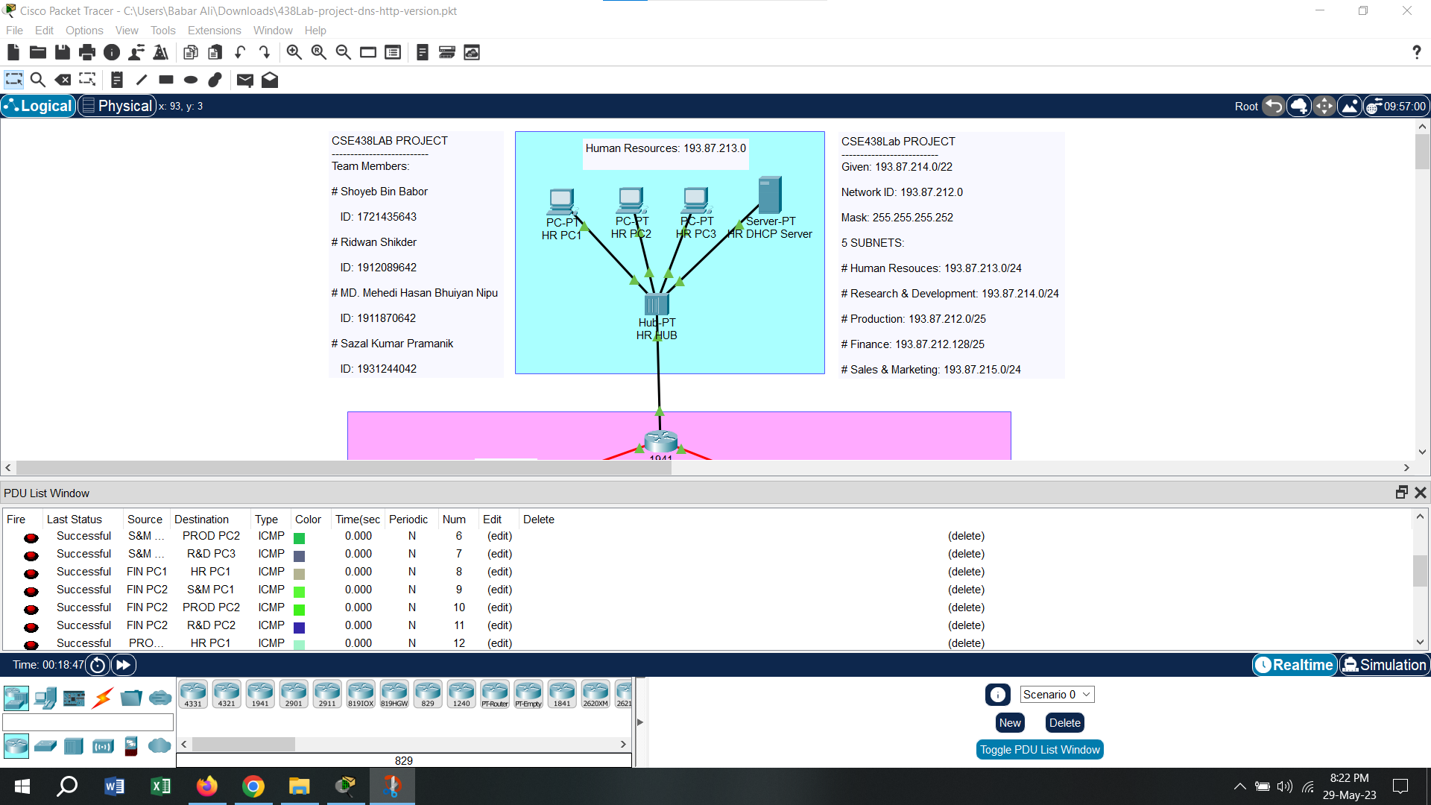

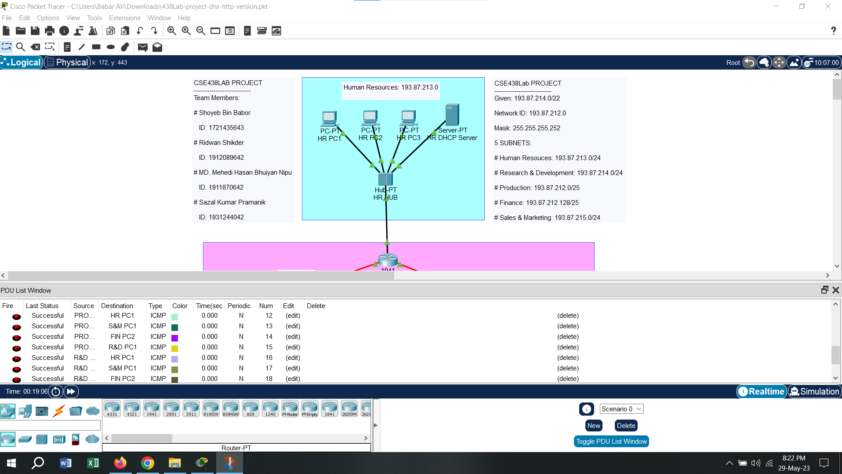

**Screenshots of the DNS & HTTP services working:**

